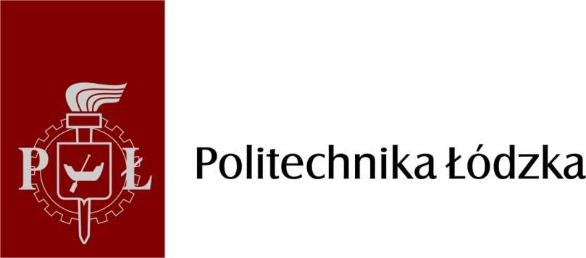

STAFF MOBILITY UNDER LEARNING MOBILITY BETWEEN PARTNER COUNTRIES (KA103) ACTION OF ERASMUS+ PROGRAMME

What needs to be done before planned mobility?

1. Application for permission to go on a mobility

At least 3 weeks before the planned mobility, an application for permission to go abroad should be submitted electronically (through the SAPort system) and personally in the Staff Mobility Division of the ICC TUL.

When filling in the application form in the SAPort system, specify that the Lodz University of Technology covers the costs of travel, and indicate ERASMUS IV as the main source of financing.

The application may be submitted without the written consent of the Erasmus+ account holder. This consent will be supplemented by Staff Mobility Division of ICC TUL.

2. Insurance

After submitting the application for permission to go on a mobility to the Staff Mobility Division of ICC TUL, you need to download the insurance policy available in the "Operations" tab. The policy should be printed out and brought for the mobility.

3. Financing agreement

On the basis of the application for permission to go on a mobility, a financial agreement will be prepared for the employee's mobility within the Erasmus+ programme to the following countries.

The agreement must be signed before the beginning of mobility in the Staff Mobility Division of the ICC TUL after agreeing an appointment date.

4. Individual financial support and lump sum for travel expenses

In order to process an order for the payment of individual support and a lump sum for travel costs, at least 3 weeks before the planned mobility, you should send electronically to the Staff Mobility Division of the ICC TUL the following data:
- the name of the bank account holder,
- address of residence,
- full bank account number to which the funds are to be transferred (IBAN),
- name of the bank where the account is held,
- bank SWIFT number.

5. Ulysses

Before starting your mobility, you should register with the Ulysses - a service of the Ministry of Foreign Affairs at the following address: https://odyseusz.msz.gov.pl/.

What needs to be checked during mobility?

1. Confirmation of Stay

The confirmation of stay should be issued on the receiving institution's letterhead at the end of the mobility and include information on the attainment of the objectives described in the Mobility Agreement.
In the case of academic staff mobility for teaching, the confirmation of stay must additionally contain information on the number of teaching hours, in accordance with the information contained in the Mobility Agreement.

The period of mobility included in the confirmation of stay should be in line with the period of mobility specified in the financing agreement.

The start date of the mobility period is the first day and the end date is the last day on which a participant in mobility must be present in the receiving institution in accordance with the Mobility Agreement.

Sample confirmation of stay (content) is available at www.cwm.p.lodz.pl, in the tab Employee mobility.

How to settle mobility?

1. Confirmation of Stay

Confirmation of stay should be submitted no later than 2 weeks after the end of mobility in the Staff Mobility Division of ICC TUL.

2. Report in Mobility Tool

An e-mail will be sent to the e-mail address indicated in the application process, generated by the Mobility Tool system, asking for an individual report of the mobility participant in the Erasmus+ programme. The report should be completed within one week of the date of receipt of the correspondence.

3. Substantive settlement of mobility

After the completed mobility, a report sent by the Staff Mobility Division of ICC TUL should be filled in. The report should be submitted within 1 month from the received correspondence.

Each of the participants in the mobility will also be invited to attend a meeting with staff and university authorities to share good practice and to present ways to disseminate the results of the mobility.

Any questions or information concerning the Erasmus+ mobility mobility between the programme countries should be directed to the Staff Mobility Division of ICC TUL:

Paulina Danieluk paulina.danieluk@p.lodz.pl tel.: 42 638 38 17

Agnieszka Roganowicz agnieszka.roganowicz@p.lodz.pl
tel.: 42 638 38 48

