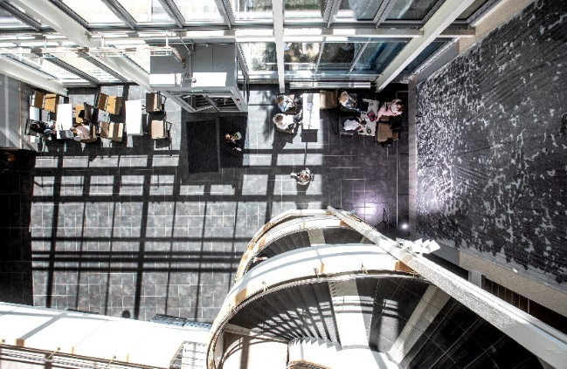
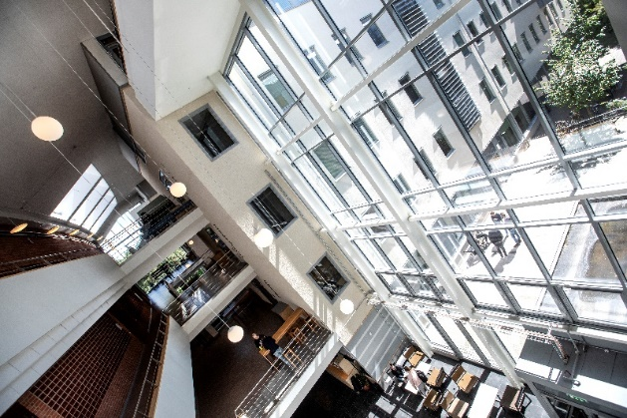

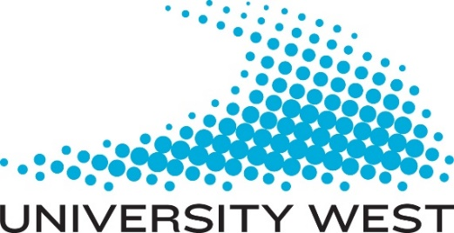
Engineering Visions 2024
A two-week international summer school
at University West in Sweden
This is an opportunity you don't want to miss – make sure to apply!
Inspirational lectures, workshops, and project work in which you participate, explore, and create technical visions in various areas with a focus on future issues. Students and teachers from several European universities will come together during these two weeks, and 4 ECTS credits is awarded each passed grade.
Dates: August 19 - August 30, 2024
(excluding travel days)
Reasons to participate:
- Small time investment
- Great experience
- Good addition to your CV
- Networking opportunities and international networking
- Develop your language skills
- Teachers from each University will accompany and participate

You will work in international student groups
and reflect on the challenges facing our world
today and create engineering visions for a
“better world”. You will also develop
awareness, sustainability, entrepreneurship,
intercultural competencies for industry and
society, multidisciplinary and innovations.
Application deadline: May 29, 2024.
If you’d like to participate, contact:
Grażyna Budzińska (grazyna.budzinska@p.lodz.pl) & Dariusz Witkowski (dariusz.witkowski@p.lodz.pl)
