Characteristics of the Papermaking Competition 2024

Participants and teams

Four-person teams consisting of two French students and two other/Polish students take part in the competitions. Team compositions are selected by drawing lots.

The competition is divided into two stages:

- Stage I: drawing teams and revealing competition tasks and competition rules (approx. 45 minutes)

- Stage II: competition (max. 180 minutes).

Between Stage I and Stage II, teams will have at least two weeks to prepare for the competition.

Communication language: English

Competitions (max. 2 tasks selected from the proposals listed below):

Task #1: "EcoTower"
Building the highest possible structure using max. 100 sheets of A4 printing paper (no glue, no paper clips) with a flat platform at the top that will hold a 2.5 kg book for at least a minute.
You can orient the book any way you want, but the height of the tower will be measured to the bottom edge of the book.

Task #2: "Paper Bag"
Making the lightest possible packaging for metal balls with a total weight of 1 kg. No materials other than paper may be used. The package must have handles that will be used to hang it on a PVC pipe with a diameter of 5 cm and a length of 1 m. The structure must hold its content for at least a minute. The weight of the empty packaging will be the main evaluation criterion.

Task #3: “Slippery slope”
Construction of a slippery slope on a flat cardboard base, with a total weight of the structure not exceeding 2000 g (may be changed), in which a metal ball with a diameter of 15 mm and a weight of 14 g will roll for as long as possible.
The ball's movement must be initiated solely by gravity. The path along which the ball moves does not have to be continuous. Time will be measured from the moment the ball starts moving until it first stops or the ball leaves the base contour. Available tools and materials: wallpaper cutter, scissors, ruler, pencils, stapler with staples, cardboard base, paper (various types), glue, paper clips, paper tape, double-sided adhesive tape.

Scoring: points from 8 (the longest travel time) to 1 (the shortest travel time).

Task #4: “Use your imagination”
Use papers in different colors and prepare a multi-layer A3 size poster illustrating a given quote.
As part of this challenge, each work should be commented by the authors (inspiration, explanation of symbolism etc.) – max. comment time: 3 minutes.

Participants create their posters during Stage II, using previously prepared designs (sketches and notes).

The works will be rated by the participants themselves on a scale from 8 (the most interesting) to 2 (the least interesting poster). Participants cannot vote for their own works.

Technique examples:
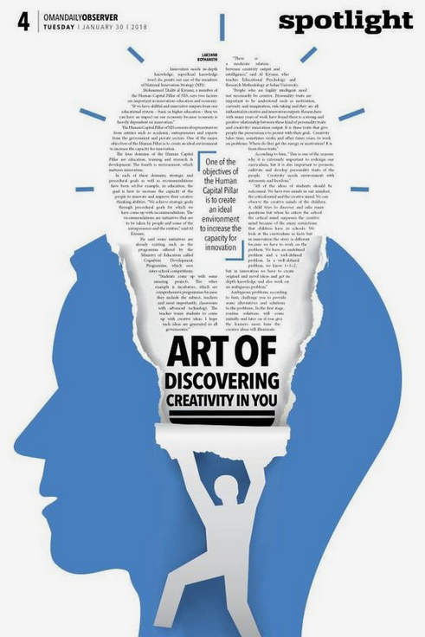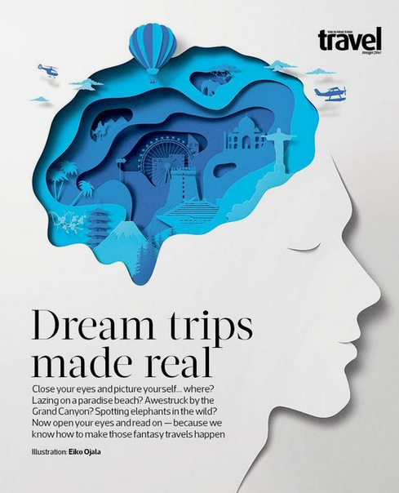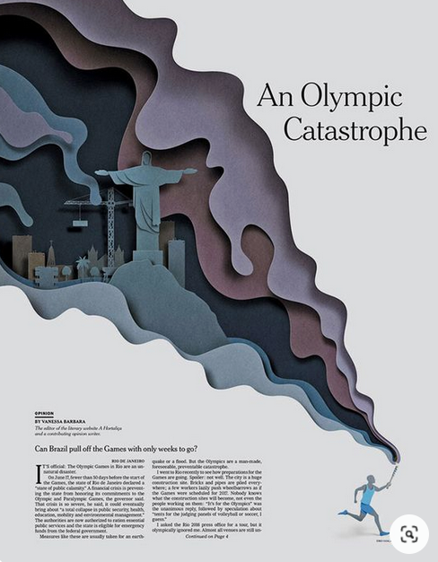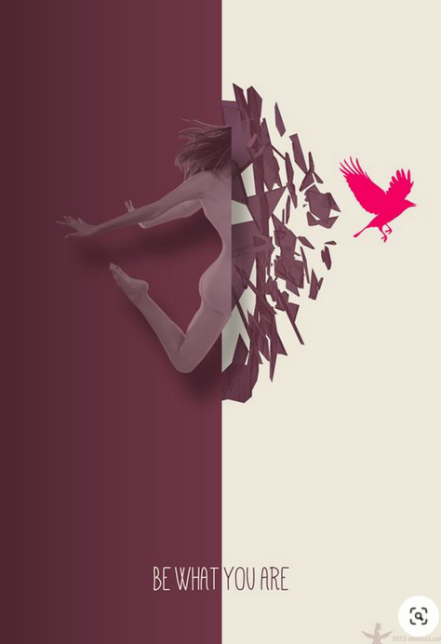

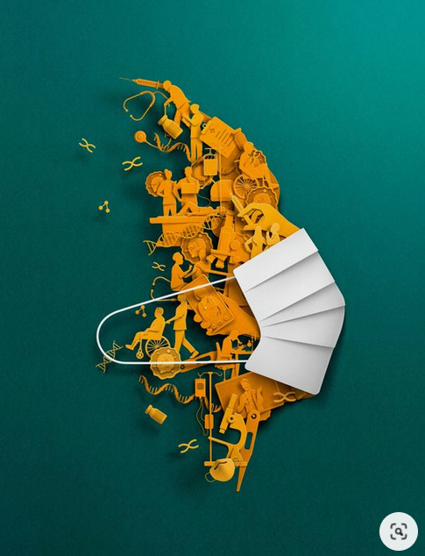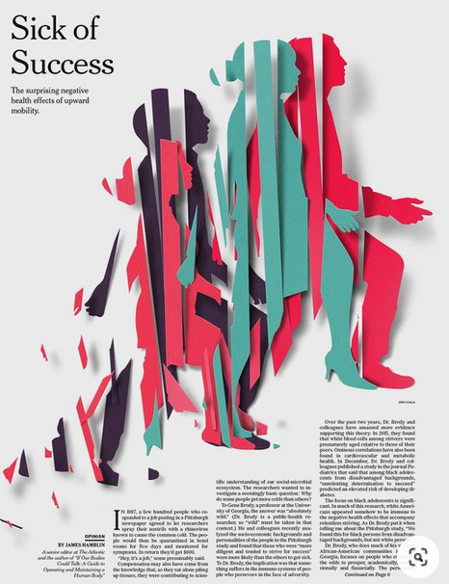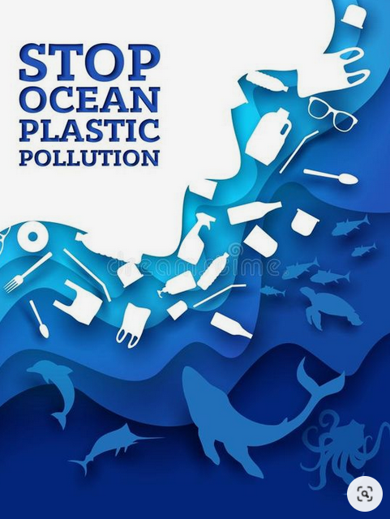

Quotation examples (the final quotation can be different):
“Success usually comes to those who are too busy to be looking for it.” -Henry David Thoreau
“Believe you can and you're halfway there." -Theodore Roosevelt
“If I have seen further it is by standing on the shoulders of Giants.” ― Isaac Newton
“It always seems impossible until it’s done.” – Nelson Mandela
The team that collects the highest sum of points from both competitions wins (places 1-3 are rewarded). The organizers provide all materials and tools necessary to complete the tasks.

Possible prizes (the organizer reserves the right to change them): portable hard drives, UGEARS models for self-assembly, powerbanks, gadgets from Lodz University of Technology

Please send your applications by e-mail to one of the following addresses:

konrad.olejnik@p.lodz.pl
cpp@adm.p.lodz.pl

We wait until May 27th. Admission is based on the order of applications.

